To be able to register, login to the website and actually view the website, you’ll need to connect to the localhost/phpMyAdmin and put the code files in the proper location on your C: drive. The following are the steps to do that:

1) Install XAMPP (or WAMP but I used XAMPP sooo I’m going with that):

Download link: <https://www.apachefriends.org/download.html>

2) Once installed, it should look like this:

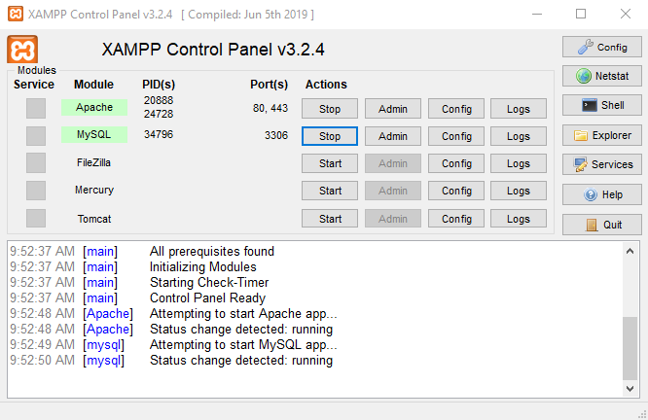

Make sure that both APACHE and MYSQL are running by clicking “START” next to both – if they highlight in green, you are good to go.

3) Go to GitHub and download the zip file “chatflix.zip” and extract files to your computer – the zip can be found in Project Documentation/Milestone 3/Vertical Prototype

4) Go to your C: drive 🡪xampp 🡪htdocs🡪paste the chatflix folder in here

5) To view the database I created (there is only one), go to browser and type in localhost/phpMyAdmin

6) On the left-hand side click “New”



7) Name the database: login_sample_db



8) Click on the database name to enter the database, and then click “IMPORT” on the top toolbar



9) Download the GitHub database sql file (users.sql) and import that file into your database

10) You should now have access to the website. The items that are functional are only login, signup, and logout! If you have any issues, let me know!